http://www.xn--whrungsrechner-5hb.org/images/schere.pnghttp://www.xn--whrungsrechner-5hb.org/images/schere.pnghttp://www.xn--whrungsrechner-5hb.org/images/schere.png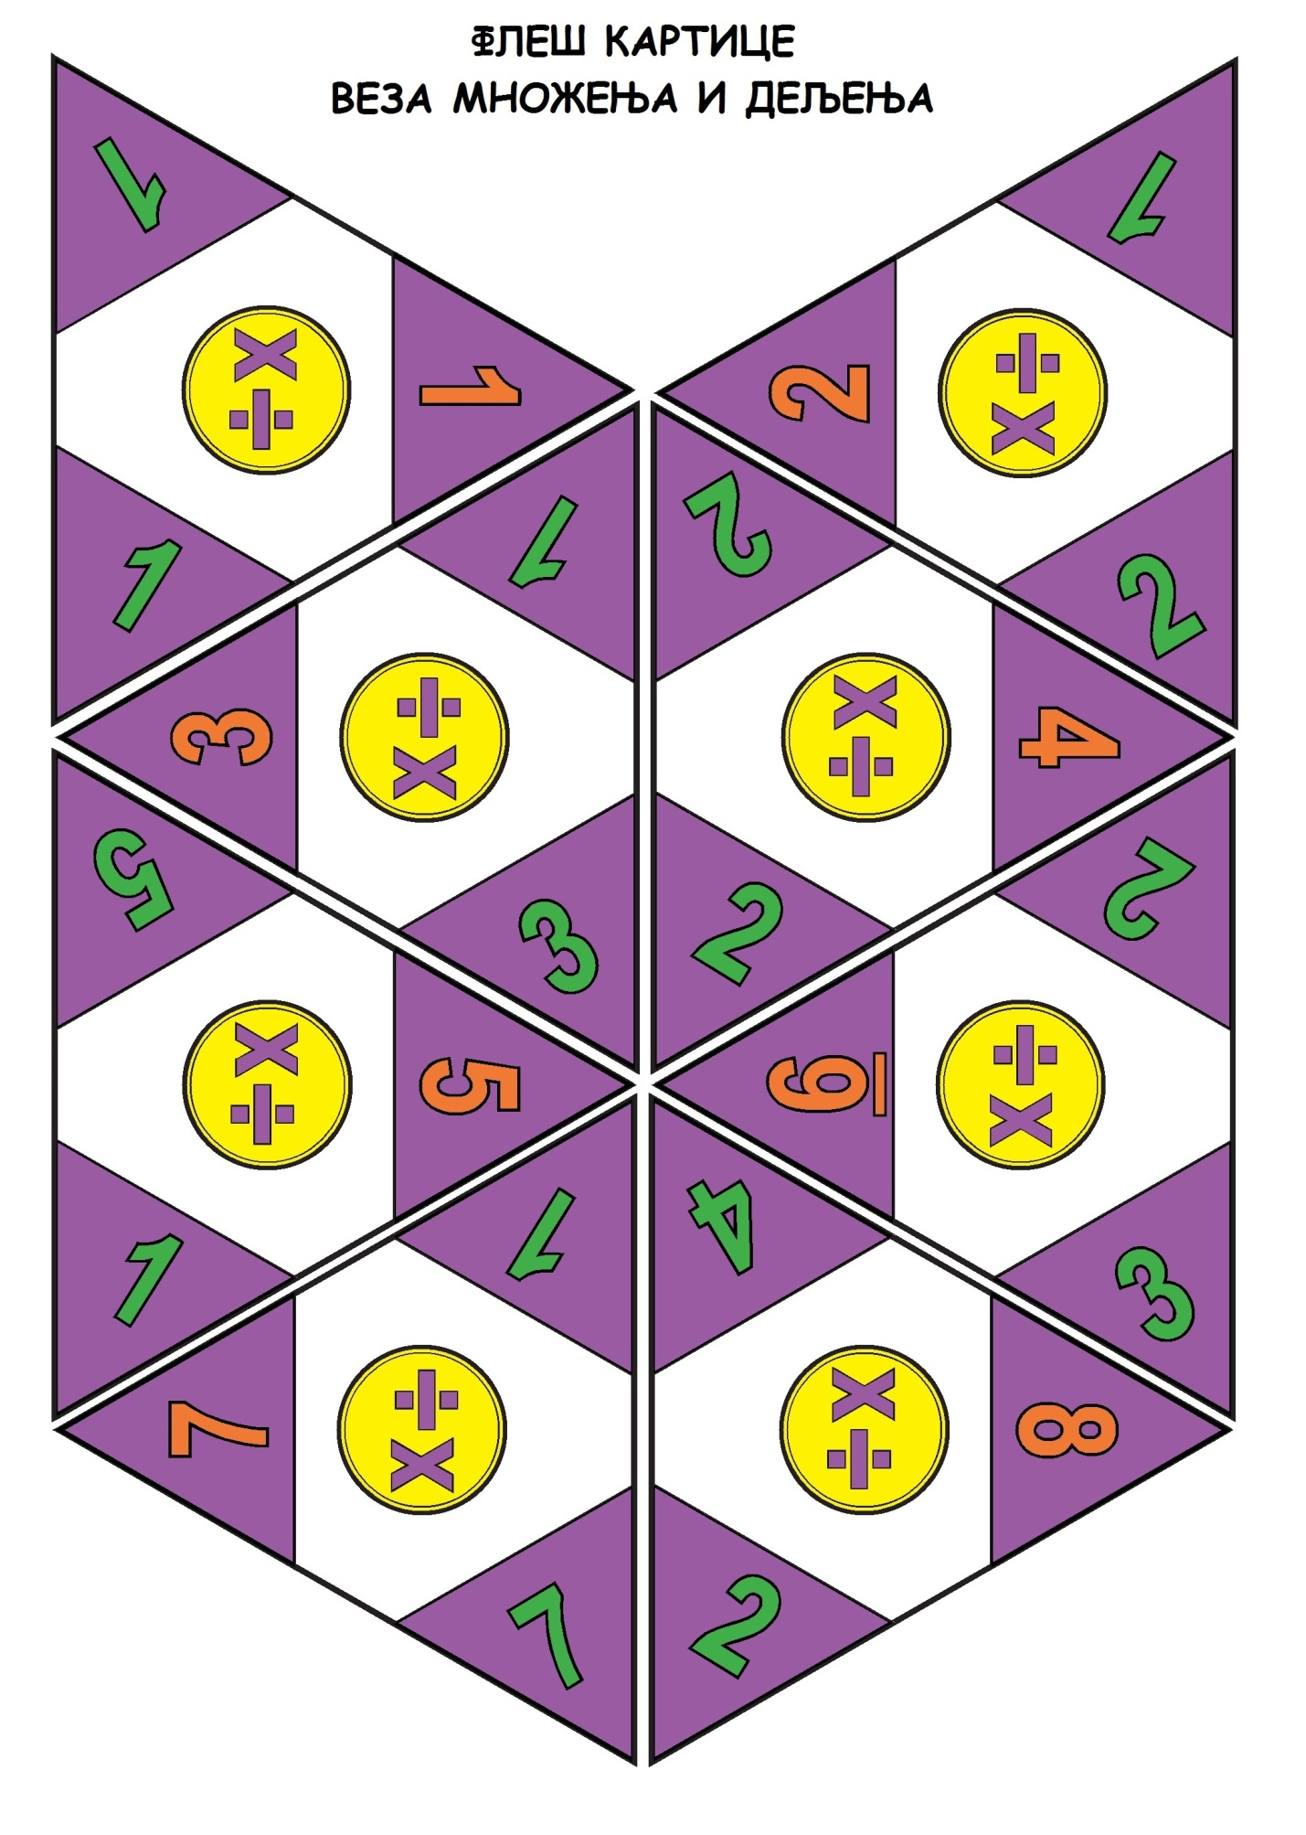

http://www.xn--whrungsrechner-5hb.org/images/schere.pnghttp://www.xn--whrungsrechner-5hb.org/images/schere.pnghttp://www.xn--whrungsrechner-5hb.org/images/schere.png