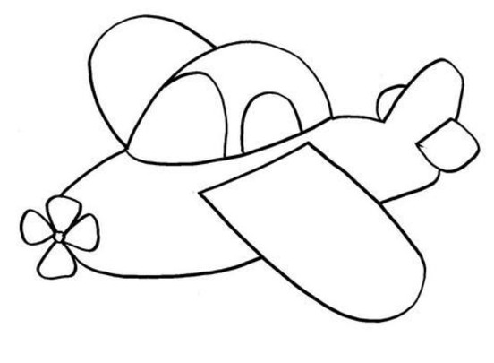 А А а а  ________________________________________________________________  ________________________________________________________________  ________________________________________________________________  ________________________________________________________________ |  |  | А А а а  ________________________________________________________________  ________________________________________________________________  ________________________________________________________________  ________________________________________________________________

