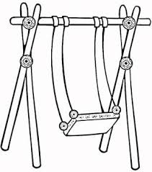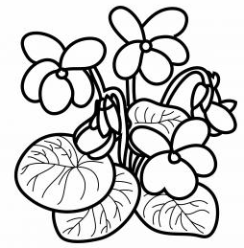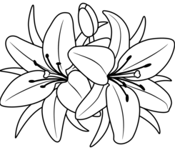  ............................................................................................................................  Љ ЉИ МУЉ  ...................................................................................................................  уље љуља Љиља  ________________________________________________________________  ________________________________________________________________  ________________________________________________________________  ________________________________________________________________ |  |  | ............................................................................................................................  Љ ЉИ МУЉ  ...................................................................................................................  уље љуља Љиља  ________________________________________________________________  ________________________________________________________________  ________________________________________________________________  ________________________________________________________________

