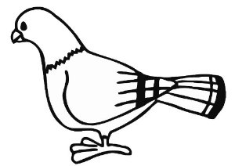  ............................................................................................................................  Г ГА ГОЛ  ...................................................................................................................  рог гора Игор  ________________________________________________________________  ________________________________________________________________  ________________________________________________________________  ________________________________________________________________ |  |  | ............................................................................................................................  Г ГА ГОЛ  ...................................................................................................................  рог гора Игор  ________________________________________________________________  ________________________________________________________________  ________________________________________________________________  ________________________________________________________________

