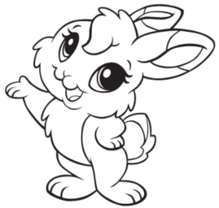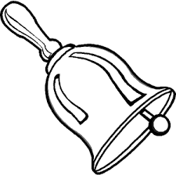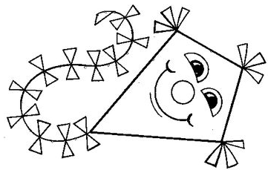  ............................................................................................................................  З ЗА УЗ  ...................................................................................................................  низ змај Зоки  ________________________________________________________________  ________________________________________________________________  ________________________________________________________________  ________________________________________________________________ |  |  | ............................................................................................................................  З ЗА УЗ  ...................................................................................................................  низ змај Зоки  .  ________________________________________________________________  ________________________________________________________________  ________________________________________________________________  ________________________________________________________________

