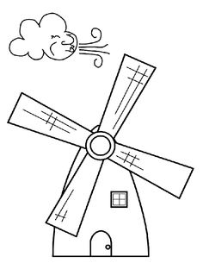  ............................................................................................................................  В ВО УВО  ...................................................................................................................  вук воз Воја  ________________________________________________________________  ________________________________________________________________  ________________________________________________________________  ________________________________________________________________ |  |  | ............................................................................................................................  В ВО УВО  ...................................................................................................................  вук воз Воја  ________________________________________________________________  ________________________________________________________________  ________________________________________________________________  ________________________________________________________________

