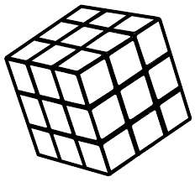  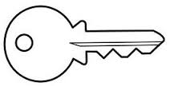  ............................................................................................................................  К КО ОКО  ...................................................................................................................  сок лако Каја .  ________________________________________________________________  ________________________________________________________________  ________________________________________________________________  ________________________________________________________________ |  |  | ............................................................................................................................  К КО ОКО  ...................................................................................................................  сок лако Каја  ________________________________________________________________  ________________________________________________________________  ________________________________________________________________  ________________________________________________________________

