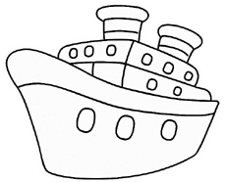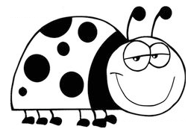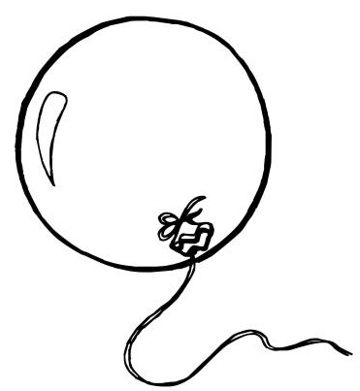  ............................................................................................................................  Б БОБ ЗОБ  ...................................................................................................................  баба Бора брод  .  ________________________________________________________________  ________________________________________________________________  ________________________________________________________________  ________________________________________________________________ |  |  | ............................................................................................................................  Б БОБ ЗОБ  ...................................................................................................................  баба Бора брод  ________________________________________________________________  ________________________________________________________________  ________________________________________________________________  ________________________________________________________________

