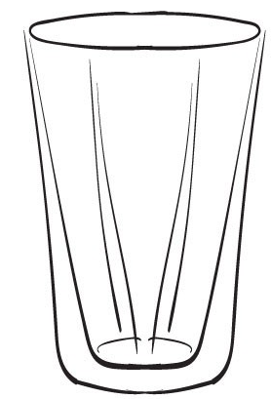  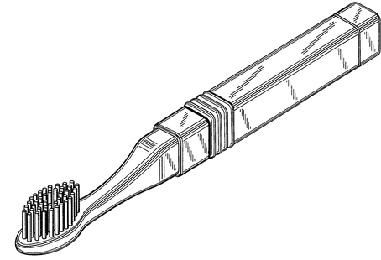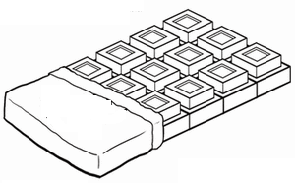  ............................................................................................................................  Ч ЧЕП ЧАЈ  ...................................................................................................................  чича чаша Чеда  ________________________________________________________________  ________________________________________________________________  ________________________________________________________________  ________________________________________________________________ |  |  | ............................................................................................................................  Ч ЧЕП ЧАЈ  ...................................................................................................................  чича чаша Чеда  ________________________________________________________________  ________________________________________________________________  ________________________________________________________________  ________________________________________________________________

