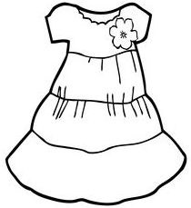  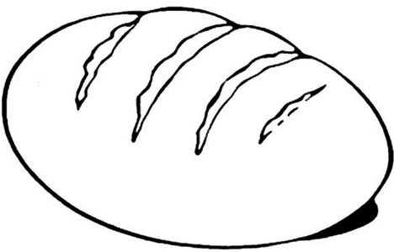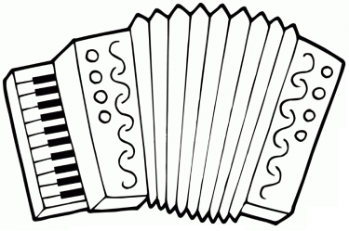  ............................................................................................................................  Х АХ ДАХ  ...................................................................................................................  Хана хлеб хвала  ________________________________________________________________  ________________________________________________________________  ________________________________________________________________  ________________________________________________________________ |  |  | ............................................................................................................................  Х АХ ДАХ  ...................................................................................................................  Хана хлеб хвала  ________________________________________________________________  ________________________________________________________________  ________________________________________________________________  ________________________________________________________________

