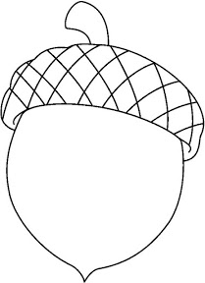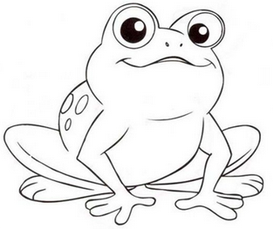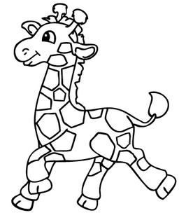  ............................................................................................................................  Ж ЖУТ ПУЖ  ...................................................................................................................  жао ружа Жика  ________________________________________________________________  ________________________________________________________________  ________________________________________________________________  ________________________________________________________________ |  |  | ............................................................................................................................  Ж ЖУТ ПУЖ  ...................................................................................................................  жао ружа Жика  ________________________________________________________________  ________________________________________________________________  ________________________________________________________________  ________________________________________________________________

