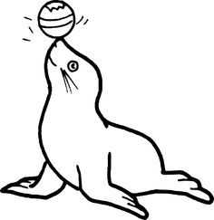  ............................................................................................................................  Ф УФ ФА  ...................................................................................................................  фил филм Филип  ________________________________________________________________  ________________________________________________________________  ________________________________________________________________  ________________________________________________________________ |  |  | ............................................................................................................................  Ф УФ ФА  ...................................................................................................................  фил филм Филип  .  ________________________________________________________________  ________________________________________________________________  ________________________________________________________________  ________________________________________________________________

