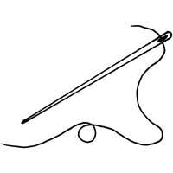  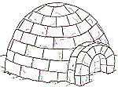  ..............................................................................................................................  И МИ ИМА  ...................................................................................................................  мама Мима имам  ________________________________________________________________  ________________________________________________________________  ________________________________________________________________  ________________________________________________________________ |  |  | ..............................................................................................................................  И МИ ИМА  ...................................................................................................................  мама Мима имам  ________________________________________________________________  ________________________________________________________________  ________________________________________________________________  ________________________________________________________________

