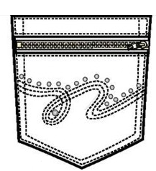  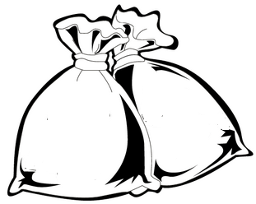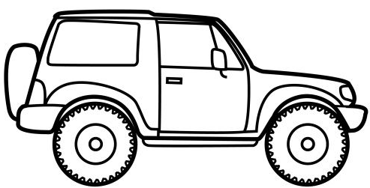  ............................................................................................................................  Џ ЏАК ЏЕП  ...................................................................................................................  џем џип оџак  ..........................................................................................................................................................  ________________________________________________________________  ________________________________________________________________  ________________________________________________________________  ________________________________________________________________ |  |  | ............................................................................................................................  Џ ЏАК ЏЕП  ...................................................................................................................  џем џип оџак  ..........................................................................................................................................................  ________________________________________________________________  ________________________________________________________________  ________________________________________________________________  ________________________________________________________________

