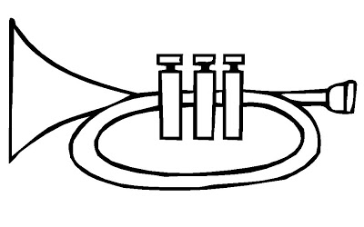  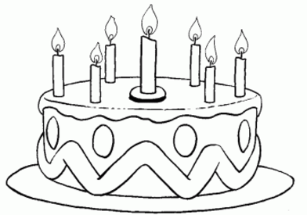  ..............................................................................................................................  Т ТА ТИ  ...................................................................................................................  тим тата Мита  ________________________________________________________________  ________________________________________________________________  ________________________________________________________________  ________________________________________________________________ |  |  | ..............................................................................................................................  Т ТА ТИ  ...................................................................................................................  тим тата Мита  ________________________________________________________________  ________________________________________________________________  ________________________________________________________________  ________________________________________________________________

