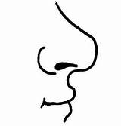  ............................................................................................................................  Н НА НИ  ...................................................................................................................  Ана нана мана  ________________________________________________________________  ________________________________________________________________  ________________________________________________________________  ________________________________________________________________ |  |  | ............................................................................................................................  Н НА НИ  ...................................................................................................................  Ана нана мана  ________________________________________________________________  ________________________________________________________________  ________________________________________________________________  ________________________________________________________________

