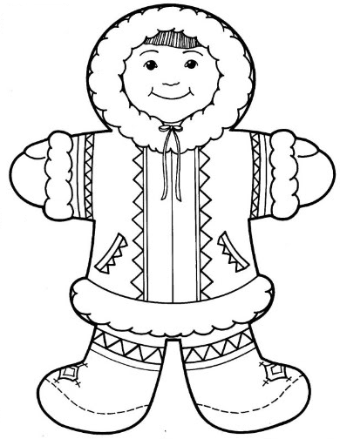  ............................................................................................................................  Е СЕ НЕ  ...................................................................................................................  Ема сено Нена  ________________________________________________________________  ________________________________________________________________  ________________________________________________________________  ________________________________________________________________ |  |  | ............................................................................................................................  Е СЕ НЕ  ...................................................................................................................  Ема сено Нена  ________________________________________________________________  ________________________________________________________________  ________________________________________________________________  ________________________________________________________________

