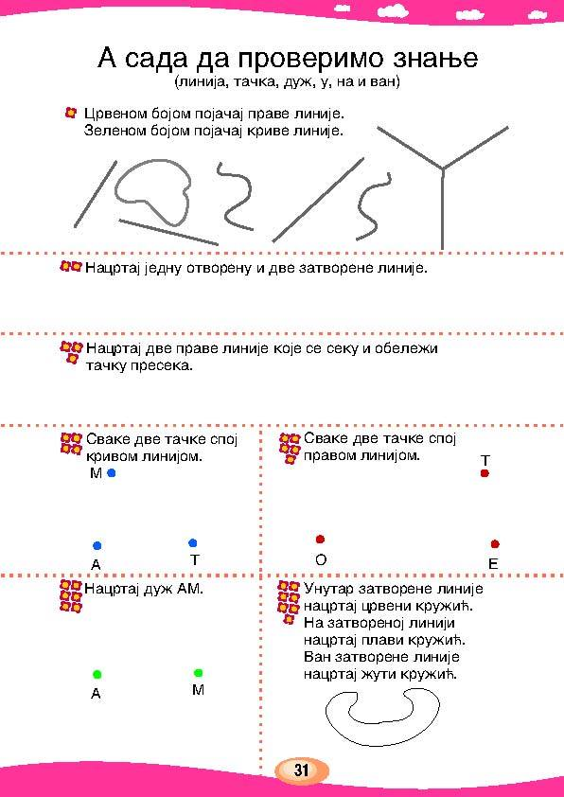

Име и презиме _________________________________________________________