5 – 1
0 + 2
3 + 2
2 + 1
4 + 1
3 + 0
4 - 0
3 - 1
2 + 2
5 – 2
2 - 0
5 - 0
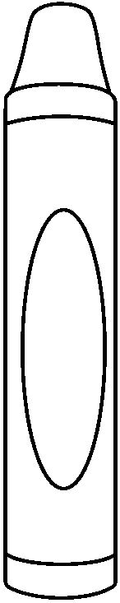
3
2
5
4

