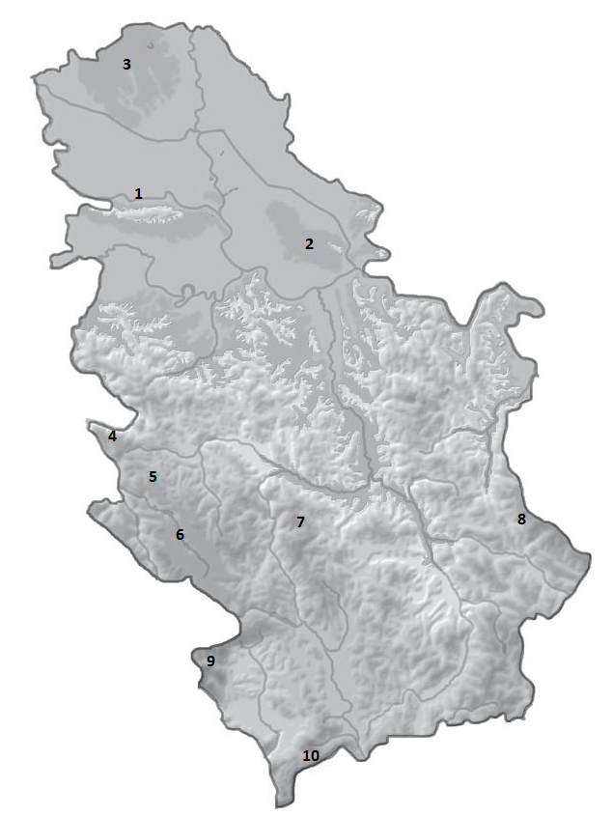

***РЕКЕ, ЈЕЗЕРА,***

***БАРЕ***

**1 __________________ 2 ________________ 3 __________________**

**4 _________________ 5 ________________ 6 _________________**

**7 __________________ 8 ________________ 9 _________________**

**10 _________________ 11 ________________ 12 _________________**

**13 _________________**

**1 __________________ 2 ________________ 3 __________________**

**4 _________________ 5 ________________ 6 _________________**

**7 __________________ 8 ________________ 9 _________________**

**10 _________________**

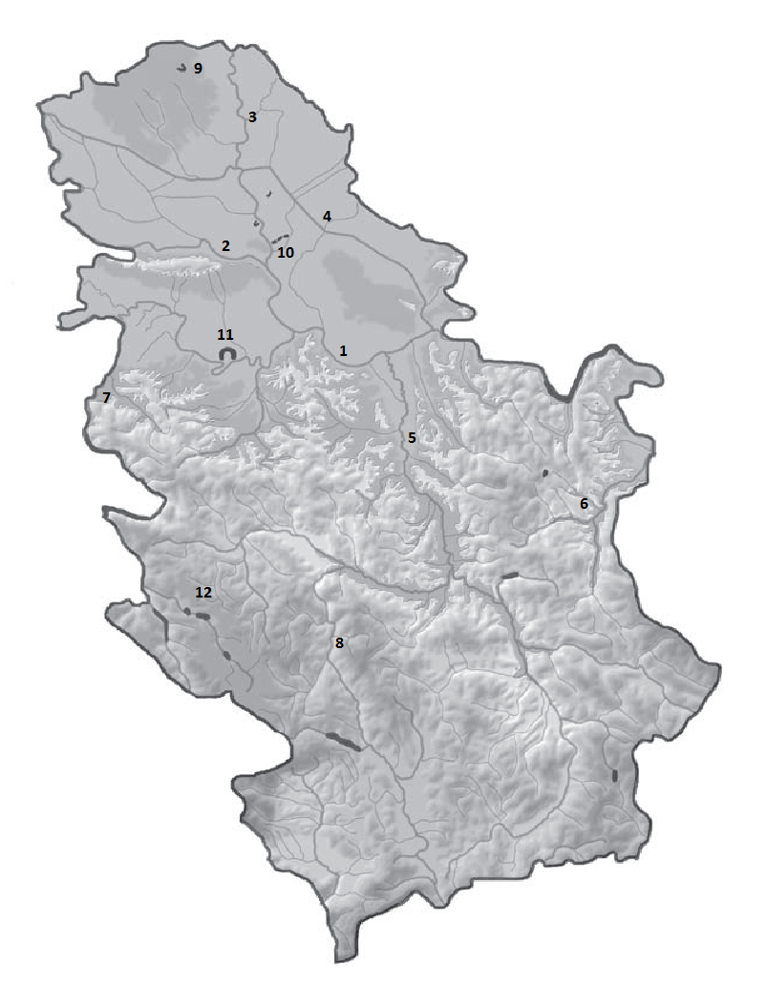

***ПЛАНИНЕ И***

***ПЕШЧАРЕ***