[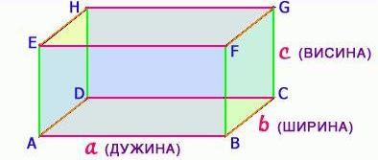](https://bp03zw.blu.livefilestore.com/y1mK5xCFG6J743z4PHv6ncMpNp0JJCbU_qI_BkQ5eyvx64po8vHyIVCaWAVxyvjV9PxDNWoK2ye4p3auBjiqWax5N27RfBN7zY_7tbrx3rFADHNNR8gr0by3xFGloF8erCnrkqtyXJosow/kvadar_d%C5%A1v%20obojena.JPG)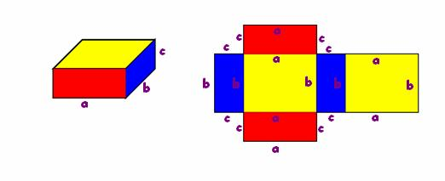

[](https://bp03zw.blu.livefilestore.com/y1mK5xCFG6J743z4PHv6ncMpNp0JJCbU_qI_BkQ5eyvx64po8vHyIVCaWAVxyvjV9PxDNWoK2ye4p3auBjiqWax5N27RfBN7zY_7tbrx3rFADHNNR8gr0by3xFGloF8erCnrkqtyXJosow/kvadar_d%C5%A1v%20obojena.JPG)



[](https://bp03zw.blu.livefilestore.com/y1mK5xCFG6J743z4PHv6ncMpNp0JJCbU_qI_BkQ5eyvx64po8vHyIVCaWAVxyvjV9PxDNWoK2ye4p3auBjiqWax5N27RfBN7zY_7tbrx3rFADHNNR8gr0by3xFGloF8erCnrkqtyXJosow/kvadar_d%C5%A1v%20obojena.JPG)[](https://bp03zw.blu.livefilestore.com/y1mK5xCFG6J743z4PHv6ncMpNp0JJCbU_qI_BkQ5eyvx64po8vHyIVCaWAVxyvjV9PxDNWoK2ye4p3auBjiqWax5N27RfBN7zY_7tbrx3rFADHNNR8gr0by3xFGloF8erCnrkqtyXJosow/kvadar_d%C5%A1v%20obojena.JPG)[](https://bp03zw.blu.livefilestore.com/y1mK5xCFG6J743z4PHv6ncMpNp0JJCbU_qI_BkQ5eyvx64po8vHyIVCaWAVxyvjV9PxDNWoK2ye4p3auBjiqWax5N27RfBN7zY_7tbrx3rFADHNNR8gr0by3xFGloF8erCnrkqtyXJosow/kvadar_d%C5%A1v%20obojena.JPG)