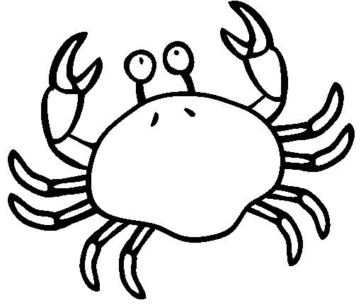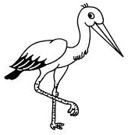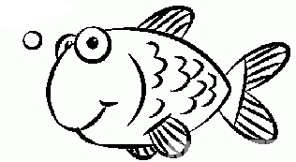  ............................................................................................................................  Р СИР РИТ  ...................................................................................................................  рис мера Maра  ________________________________________________________________  ________________________________________________________________  ________________________________________________________________  ________________________________________________________________ |  |  | ............................................................................................................................  Р СИР РИТ  ...................................................................................................................  рис мера Maра  ________________________________________________________________  ________________________________________________________________  ________________________________________________________________  ________________________________________________________________

