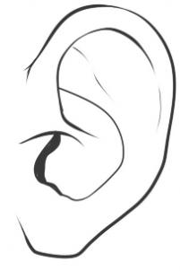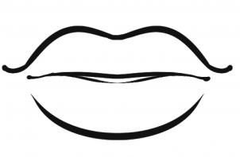  ............................................................................................................................  У СУ УНА  ...................................................................................................................  уста Рума ујна  ________________________________________________________________  ________________________________________________________________  ________________________________________________________________  ________________________________________________________________ |  |  | ............................................................................................................................  У СУ УНА  ...................................................................................................................  уста Рума ујна  ________________________________________________________________  ________________________________________________________________  ________________________________________________________________  ________________________________________________________________

