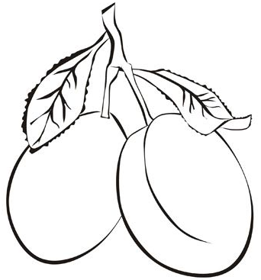  ............................................................................................................................  Ш ИШ УШИ  ...................................................................................................................  шум шума Маша  ________________________________________________________________  ________________________________________________________________  ________________________________________________________________  ________________________________________________________________ |  |  | ............................................................................................................................  Ш ИШ УШИ  ...................................................................................................................  шум шума Маша  ________________________________________________________________  ________________________________________________________________  ________________________________________________________________  ________________________________________________________________

