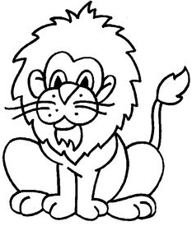  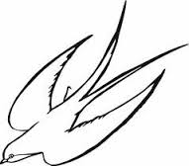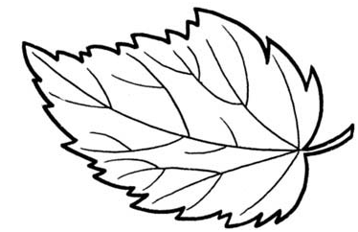  ............................................................................................................................  Л ЛА ЛАН  ...................................................................................................................  лане лала Лена  ________________________________________________________________  ________________________________________________________________  ________________________________________________________________  ________________________________________________________________ |  |  | ............................................................................................................................  Л ЛА ЛАН  ...................................................................................................................  лане лала Лена  ________________________________________________________________  ________________________________________________________________  ________________________________________________________________  ________________________________________________________________

