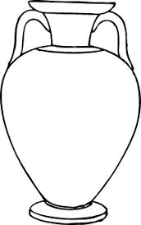  ............................................................................................................................  Ћ ЋУП КАЋ  ...................................................................................................................  ћук ћути Ћира  ________________________________________________________________  ________________________________________________________________  ________________________________________________________________  ________________________________________________________________ |  |  | ............................................................................................................................  Ћ ЋУП КАЋ  ...................................................................................................................  ћук ћути Ћира  ________________________________________________________________  ________________________________________________________________  ________________________________________________________________  ________________________________________________________________

