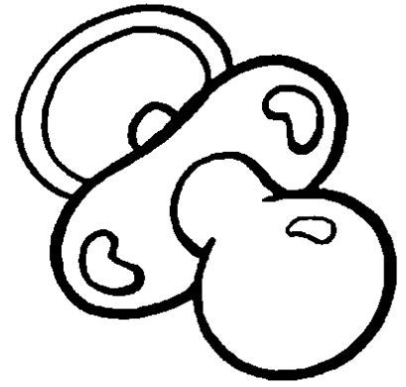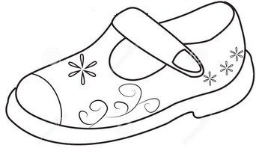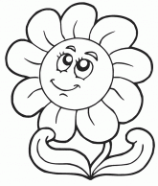  ............................................................................................................................  Ц АЦА ЦИЉ  ...................................................................................................................  маца цвет Цана  ________________________________________________________________  ________________________________________________________________  ________________________________________________________________  ________________________________________________________________ |  |  | ............................................................................................................................  Ц АЦА ЦИЉ  ...................................................................................................................  маца цвет Цана  .  ________________________________________________________________  ________________________________________________________________  ________________________________________________________________  ________________________________________________________________

