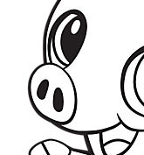  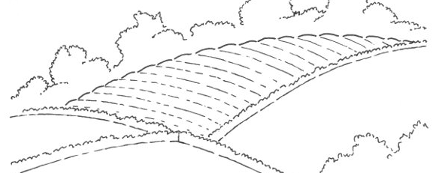  ............................................................................................................................  Њ КОЊ ТАЊА  ...................................................................................................................  Сања њива њаче  ________________________________________________________________  ________________________________________________________________  ________________________________________________________________  ________________________________________________________________ |  |  | ............................................................................................................................  Њ КОЊ ТАЊА  ...................................................................................................................  Сања њива њаче  ________________________________________________________________  ________________________________________________________________  ________________________________________________________________  ________________________________________________________________

