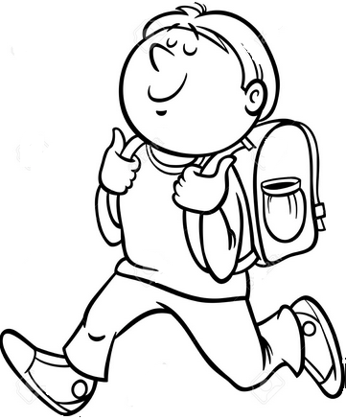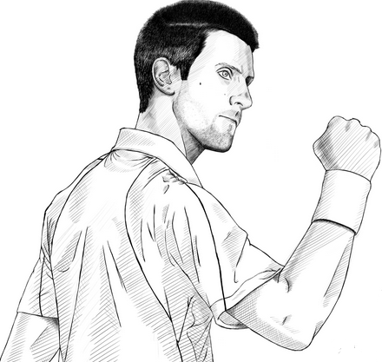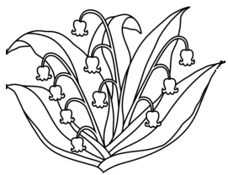  ............................................................................................................................  Ђ ЂАК РЂА  ...................................................................................................................  Ђура смуђ смеђ  ________________________________________________________________  ________________________________________________________________  ________________________________________________________________  ________________________________________________________________ |  |  | ............................................................................................................................  Ђ ЂАК РЂА  ...................................................................................................................  Ђура смуђ смеђ  .  ________________________________________________________________  ________________________________________________________________  ________________________________________________________________  ________________________________________________________________

