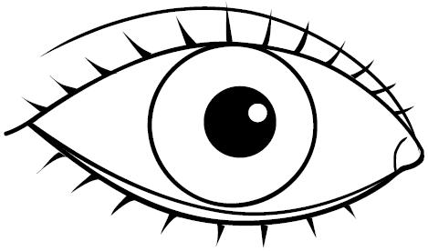  ............................................................................................................................  O TO ОМА  ...................................................................................................................  Мoма Тома омот  ________________________________________________________________  ________________________________________________________________  ________________________________________________________________  ________________________________________________________________ |  |  | ............................................................................................................................  O TO ОМА  ...................................................................................................................  Мoма Тома омот  ________________________________________________________________  ________________________________________________________________  ________________________________________________________________  ________________________________________________________________

