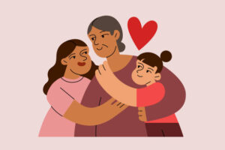

1. Betty and Frank ______ a really nice aunt.
- have got
- has got

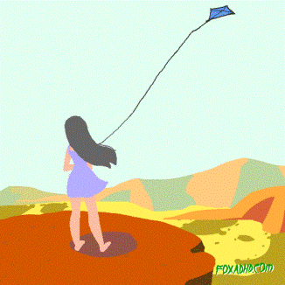

2. Katy _____ a kite.
- haven't got
- hasn't got
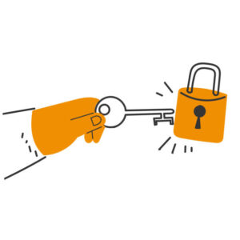

3. I can't open the door. I ______a key. (-)
- has got
- haven't got
- have got

4. My parents ______ a big bedroom.
- have got
- has got

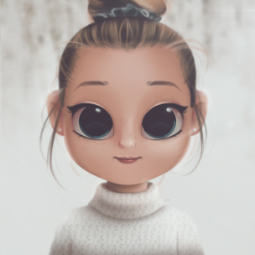

5. _____ she _____ big eyes?
- Have, got
- Has, got

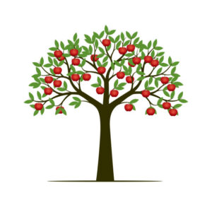

6. We ______ an apple tree in the garden.
- has got
- have got
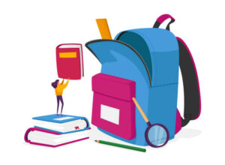

7. What _____ you ______ in your schoolbag?
- has, got
- have, got
- got, have

8. Hurry up! We _____ much time. (-)
- have got
- hasn't got
- haven't got
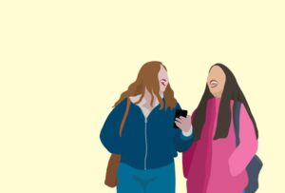

9. My sisters _____ long hair.
- have got
- has got

10. They _____ two cats and a dog.
- has got
- have got

11. Robert ______ a lot of friends in school.
- have got
- has got

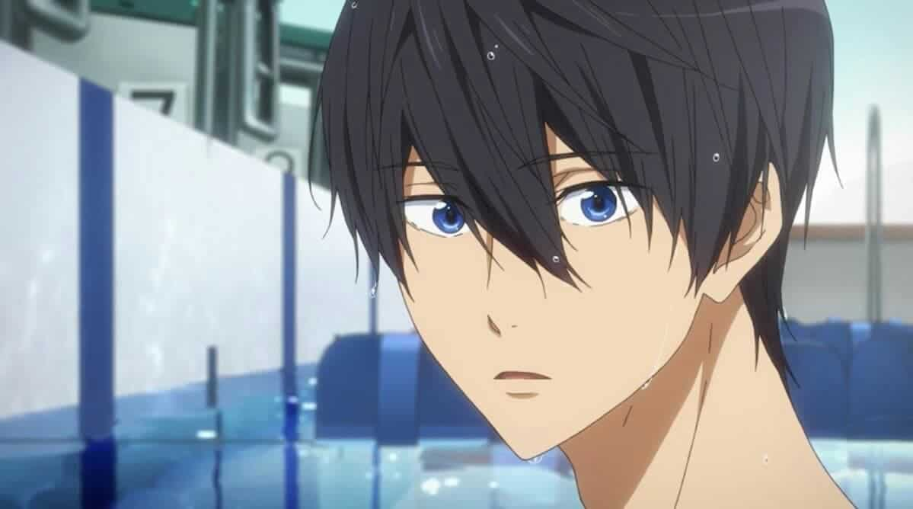

12. Max _____ got black hair.
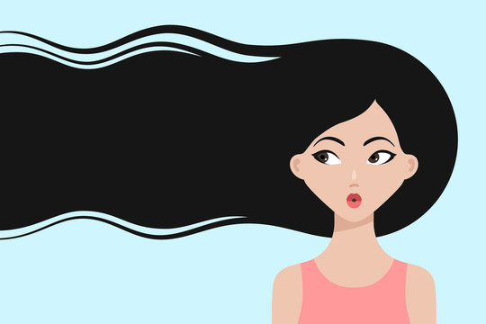

13. My sister _______ long hair.
- haven't got
- hasn't got

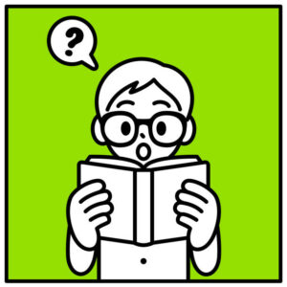

14. Обрати пажњу на минус! Ben ______ a lot of books. (-)
- haven't got
- hasn't got
- has got

15. I ______ enough time to go on holidays.
- has got
- hasn't got
- have got

