1. (I) ____ book is interesting.
- your
- my
- his

2. (your brother) ____ hair is long.
- its
- your
- his

3. (the boys) ____ father is rich.
- your
- their
- his

4. (my dog) ____ tail is very long.
- its
- his
- her

5. (Justine and I) ____ village is small.
- our
- their
- my

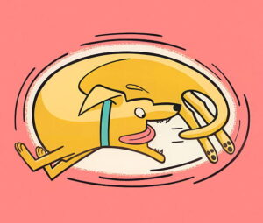

6. Find the possessives: The dog is chasing its tail.
- its
- The
- tail
- is
- dog
- chasing

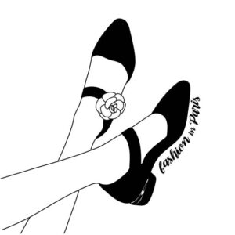

7. (the girl) ____ shoes are expensive.
- his
- her
- its
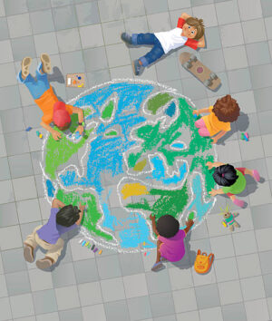

8. (they) ____ children are playing.
- their
- our
- your

9. (we) ____ friends live in Lugo.
- our
- their
- your

10. (you) ____ car is new.
- my
- his
- your

11. Find the possessives: Saturday is my favourite day.
- my
- favourite
- day
- is
- Saturday

12. (Jasmine) ____ house is very nice.
- his
- its
- her

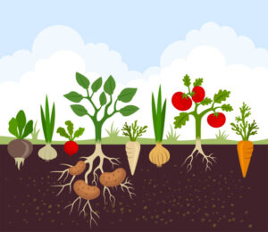

13. (he and Mary) ____ garden is beautiful.
- our
- their
- your

14. Find the possessives: Her car is very expensive.
- Her
- car
- expensive
- is
- very

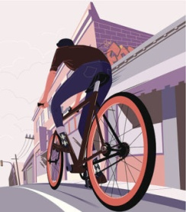

15. (the bike) ____ wheels are big.
- its
- his
- her

