1. _______ is my father.
- This
- That
- These
- Those

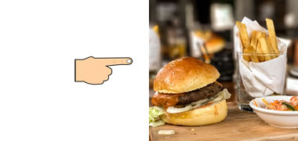

2. Don't eat _______ food!
- this
- that
- these
- those

3. ________ are my friends.
- This
- That
- These
- Those

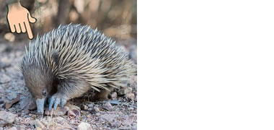

4. Where does _______ animal live?
- this
- that
- these
- those
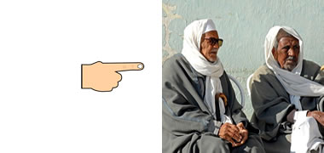

5. Who are _______ men?
- this
- that
- these
- those

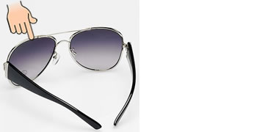

6. Are _______ your glasses?
- this
- that
- these
- those

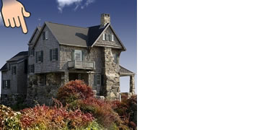

7. Who lives in _______ house?
- this
- that
- these
- those

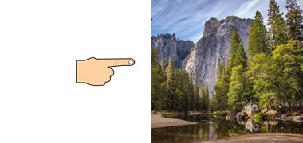

8. We are going to climb _______ mountains.
- this
- that
- these
- those
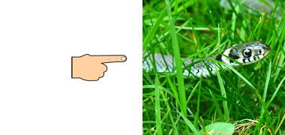

9. Look at ________ snake!
- this
- that
- these
- those

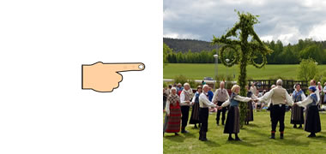

10. _______ people are dancing.
- This
- That
- These
- Those

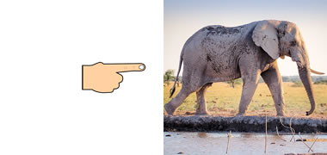

11. _______ elephant is very big.
- This
- That
- These
- Those
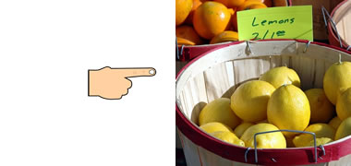

12. How much are ______ lemons?
- this
- that
- these
- those
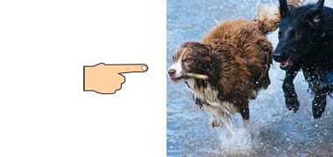

13. Are _______ your dogs?
- this
- that
- these
- those

14. Can we read _______ books?
- this
- that
- these
- those

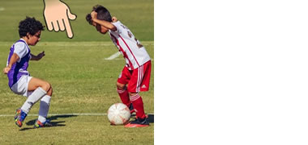

15. _______ boys are playing football.
- This
- That
- These
- Those

