1. The husband of your aunt is your uncle.
- Тачно
- Нетачно

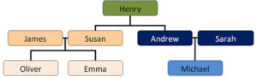

2. Sarah is Michael's _______.
- aunt
- mother
- sister

3. Реши ребус: reptans
_______________.

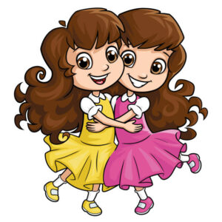

4. They are...
- brothers
- sisters
- grandmothers

5. Michael is Oliver's ________.
- uncle
- brother
- cousin

6. Oliver is Emma's _______.
- father
- aunt
- brother

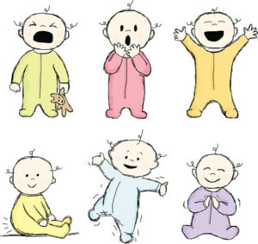

7. This is a...
- uncle
- baby
- mother

8. Како се на енглеском језику каже - породица?
- parents
- family
- cousin

9. Henry is Emma's _________.
- father
- mother
- grandfather

10. Andrew is Michael's ________.
- uncle
- grandfather
- father

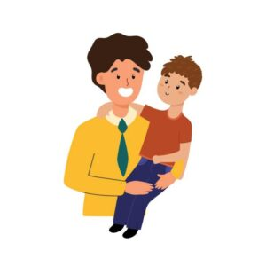

11. The son of your sister is your...
- bride
- dauther
- nephew

12. Реши ребус: bandhus
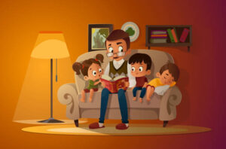

13. Штиклирај шта видиш на слици:
- aunt
- grandsons
- grandfather
- granddaughter
- mother

14. Michael is Henry's _______.
- grandfather
- grandson
- grandparent

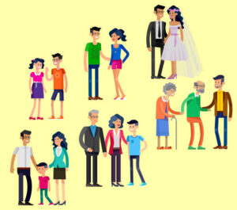

15. Your brother's wife is your...
- cousin
- sister
- sister-in-law

